

Open Automation
Mechatronic Framework, Components & Tools

Version: 1.0
Release date: November 2012
Author:
Stefano Carabelli
Dipartimento di Automatica ed Informatica
Politecnico di Torino

This work is licensed under a
Creative Commons Attribution-NonCommercial-ShareAlike 3.0 Italy License.
Executive summary
I testi e le figure riportate nel seguito sono intesi per la realizzazione del poster di presentazione del progetto.
Table of Contents
Project logo and website 4
Mechatronic Framework 5
OpenECU & OpenPLC 6
Development and embedded software 8
Wireless Link and Low-Latency Video Feedback 9

Project logo and website link


Mechatronic Framework
Open Automation project main goal is to bring the concept of Open Source into the basic components to build mechatronic products. Open Source is usually defined as related to software code to be freely available both for usage and redistribution. The Open Source concept is here extended to the description code, i.e. schematics, of hardware components: Open Hardware.
The Mechatronic Framework is a conventional way to systematically describe the different parts of a mechatronic product and their interfaces. Such a description allows to build a dynamic model as well as a real prototype with a systematic approach and the usage of ready to use components to reduce the concept to product time lapse.
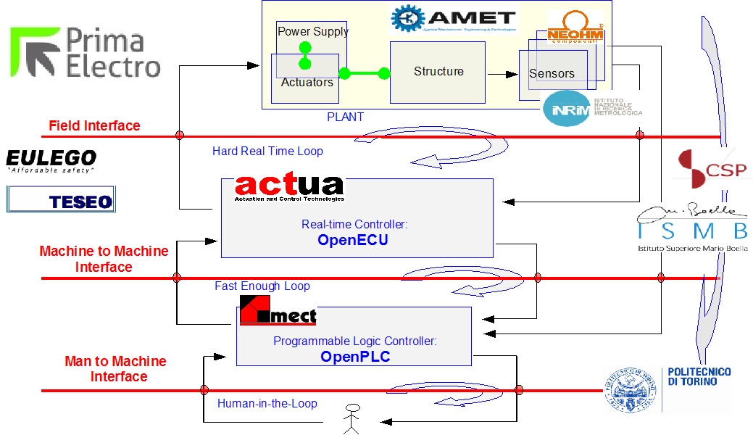Mechatronic Framework and Project Partners for MESAP FAROS Project

OpenECU & OpenPLC
The Electronic Control Unit (ECU) is a Digital Signal Processor (DSP) and Field Programmable Gate Array (FPGA) based programmable platform for the real-time control of any kind of electric driven actuators.
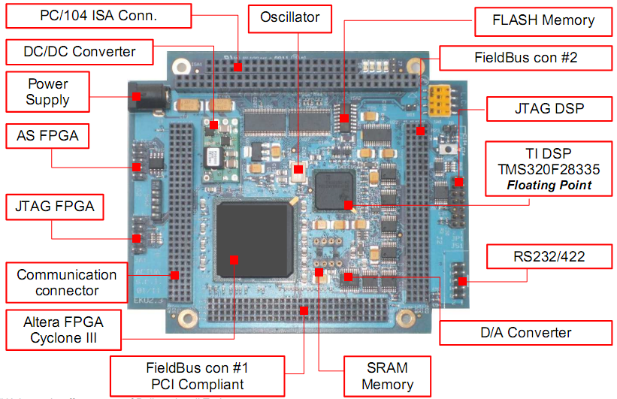Open Electronic Control Unit (OpenECU)
Together with suitable size of power modules ECU implements a fully software and firmware programmable Actuation Control Unit (ACU) to prototype and test mechatronic solutions in many different fields: from transportation to industrial automation, to renewable sources.
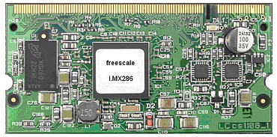
Open Programmable Logic Controller (OpenPLC)

The Programmable Logic Control (PLC) is an ARM9 based programmable platform with CANOpen interface and Xenomai Flexcan device driver.
OpenECU (OpenACU) and OpenPLC provide the Open Hardware components to implement real world automation architectures to cope with many different field of application.
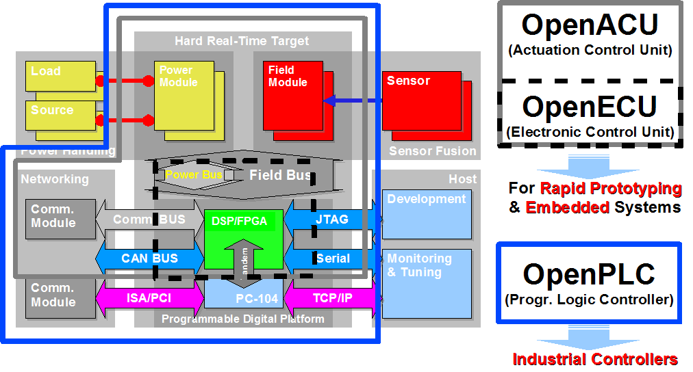Combinations of Open Programmable Digital Platforms.

Development and embedded software
A hard real-time, i.e. deterministic, operating system for the programming of the OpenECU digital platform has been developed to be used in the most stringent operating conditions of embedded actuation and control software.
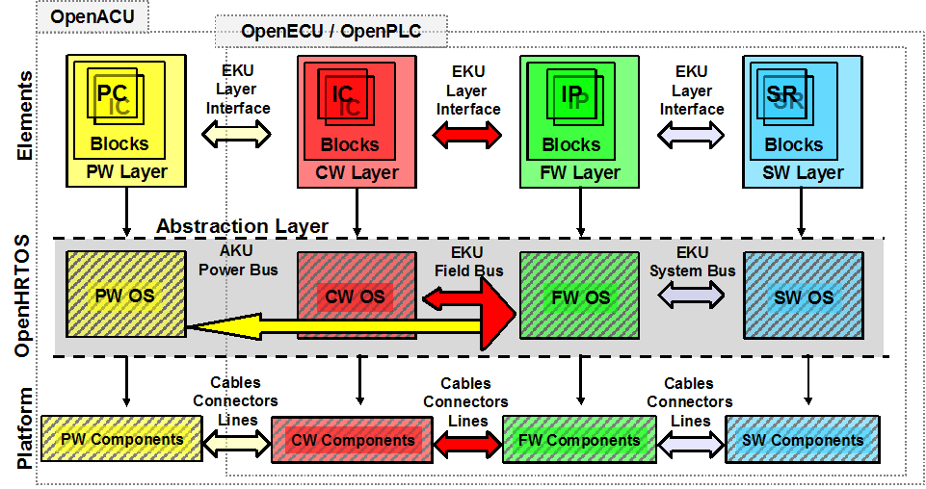Hard Real-Time Operating System (HRTOS) as a digital platform abstraction.
A Matalb-Simulink based environment for the design and simulation of control laws for motion control is also available with Hardware-in-the-Loop capabilities.
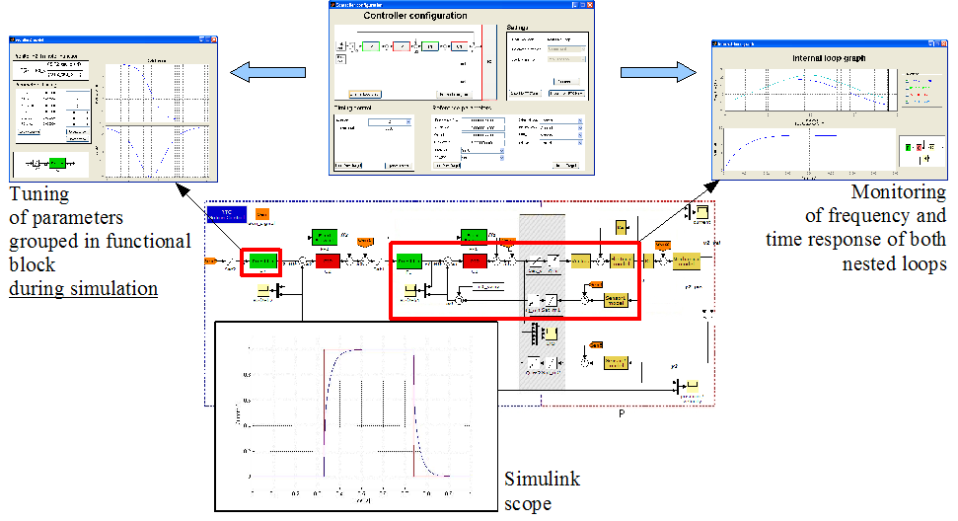Open Motion Control development environment

Wireless Link and Low-Latency Video Feedback
A wireless link featuring real-time performance, fail-over system, auto-configuration and per-flow priorities has been implemented using low-cost Commercial Off-The-Shelf (COTS) hardware.
To enable remote control applications with stingent latency requirements, on top of the real-time wireless channel, an implementation of an ultra-low delay video channel has been implemented by means of an Open Camera - that features a CMOS device directly linked to powerful FPGA - and a very Low-Latency Streaming Toolchain - that also implements rate adaptation and error resilience techniques to counterbalance the time varying nature of the network channel.
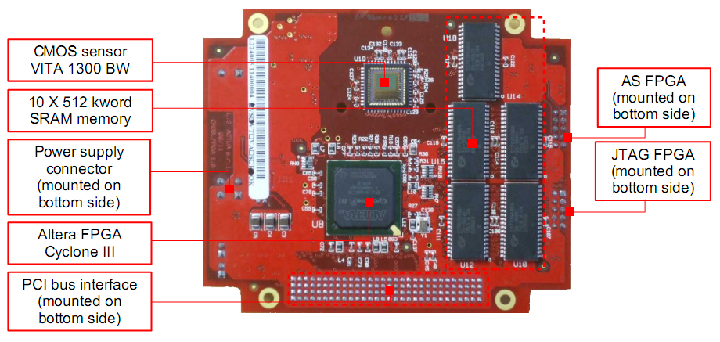Open Camera
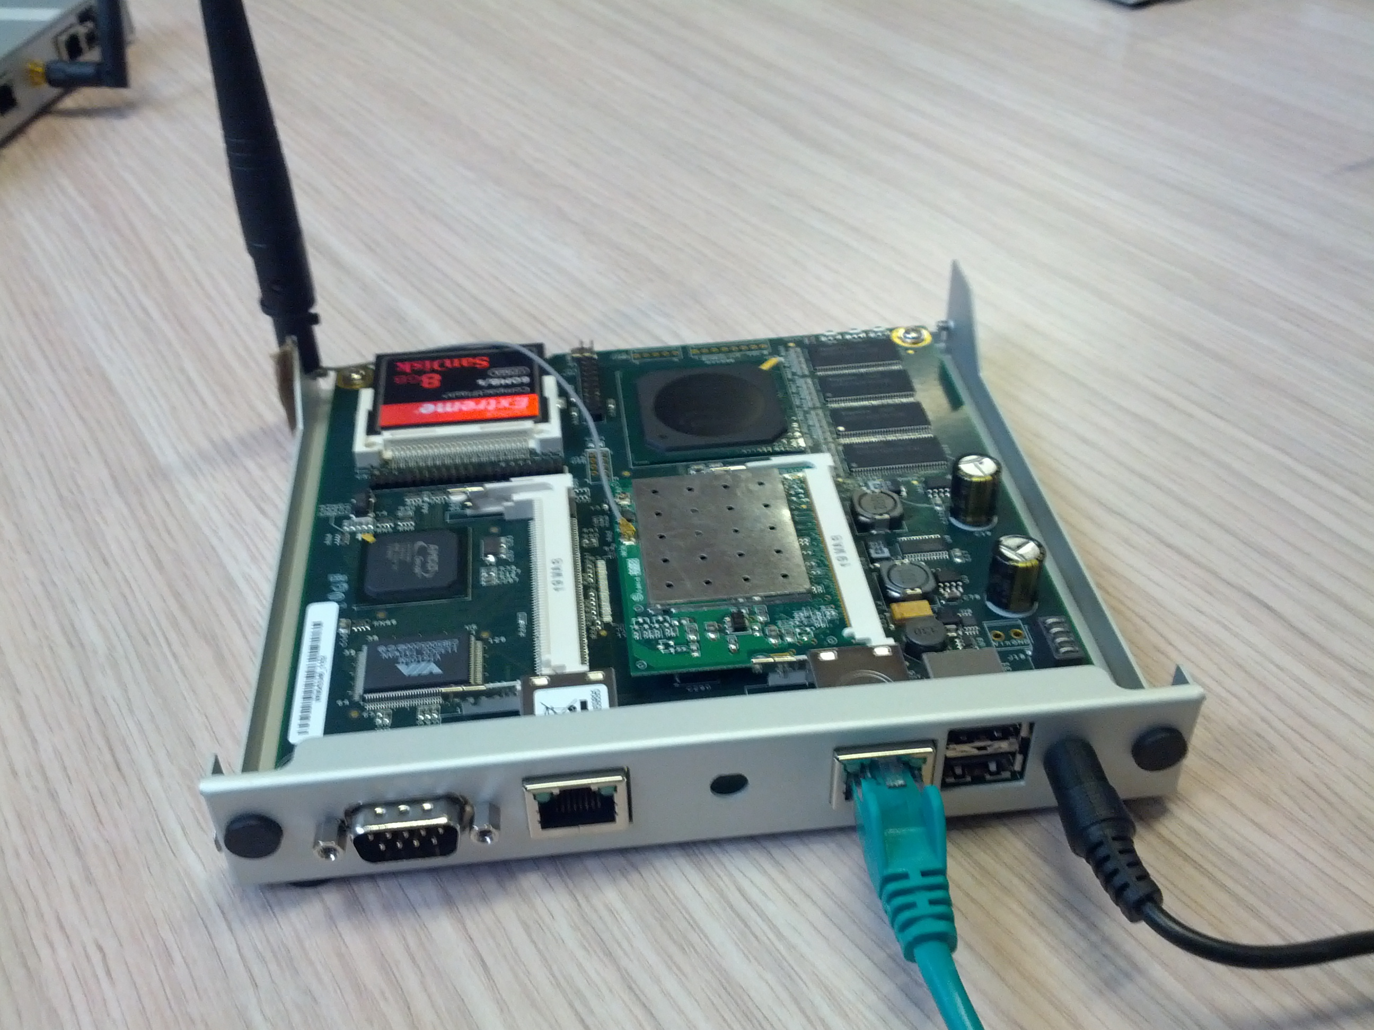Wireless link

